Enabling G+ API on Google Console

In order to consume google plus services, first we need to enable the Google Plus API on google console and we need to register our digitally signed .apk file’s public certificate in the Google APIs Console.

**1)** Java **keytool** can be used to generate SHA-1 fingerprint. Open your terminal and execute the following command to generate SHA-1 fingerprint. If it ask for password, type **android** and press enter.

**On windows**

*keytool -list -v -keystore "%USERPROFILE%\.android\debug.keystore" -alias androiddebugkey -storepass android -keypass android*

|  |
| --- |
|  |

**On Linux or Mac OS**

*keytool -list -v -keystore ~/.android/debug.keystore -alias castpocketkey -storepass 32edqdxqwd1dqa -keypass 9u087bvya21xa*

|  |
| --- |
|  |

In the output you can notice SHA1 fingerprint.

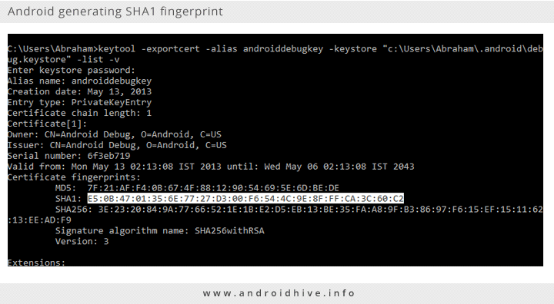

**1.2)** Open [Google APIs console](https://code.google.com/apis/console)

**1.3)** On the left, under **APIs & auth** section, click on **APIs** and on the right enable **Google+ API** service.

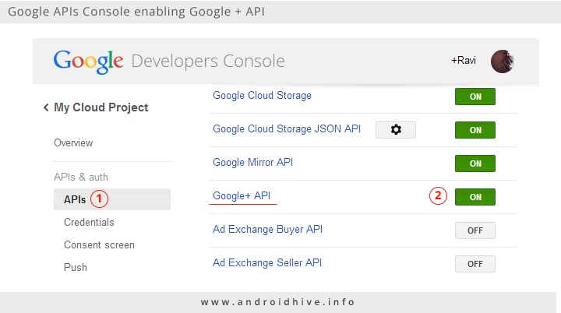

**1.4)** Now again on the left, click on **Credentials** and on the right, click on **CREATE NEW CLIENT ID**button. It will open a popup to configure a new client id.

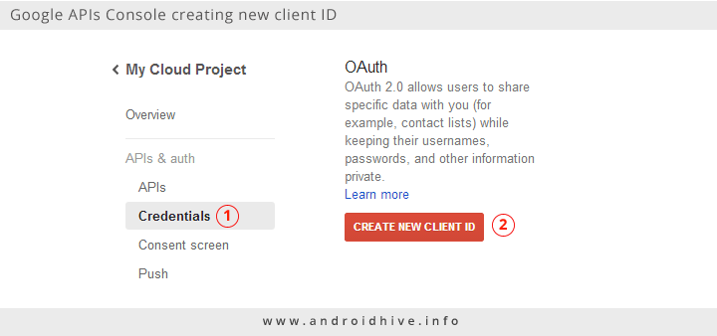

**1.5)** In the popup, select **Installed application** as Application type.

**1.6)** Under Installed application type section select **Android** and give your project **package name**. This package name should be equal to your android project. I gave my package name as**info.androidhive.gpluslogin**

**1.7)** Enter your **SHA1** fingerprint in **Signing certificate fingerprint (SHA1)** field.

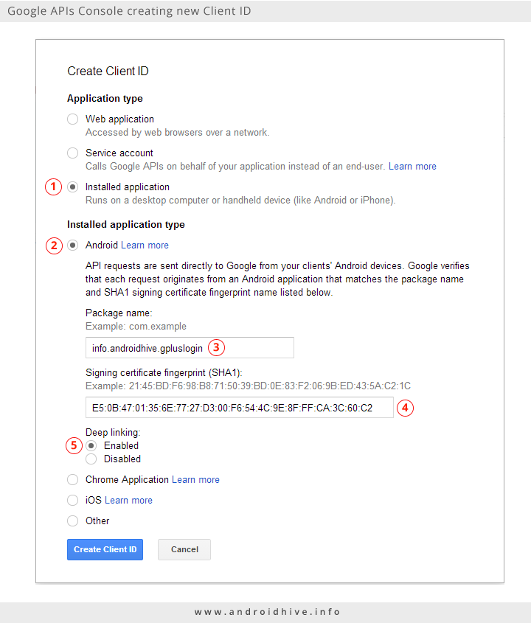**1.8)** Enable **Deep Linking** and click on Create Client ID button. Now you should see a new client created for your android pplication.

